**DSA-210**

**FINAL REPORT**

**Car Tire Pressure – Temperature**

**Efe Utku Ural**

**33991**

**Project Overview**

This project looks into how driving and environmental factors relate to tire pressure in cars. Data gathered from March 13 to April 25, 2025, using a Tesla Model Y Standard Edition (single motor) is the main focus of the analysis. This study takes into account the effects of driving distance, altitude, car load, and outside temperature on tire pressure.

**Motivation**

As someone who drives daily to Sabancı University and other common destinations, I wanted to know how various outside factors would influence the tire pressure of my vehicle. This tracks tire condition and enhances vehicle maintenance plans.

**Dataframe**

**Timeframe:** March 13, 2025 – April 25, 2025  
**Vehicle:** Tesla Model Y Standard Edition (Single Motor)

**Data Columns:**

* Date
* Average Tire Pressure (PSI)
* Temperature (Celsius and Fahrenheit)
* Altitude (based on destination elevation)
* Car Load (kg) — includes personal weight (65kg), fixed cargo (30kg), and added weights from friends or family.
* Driving Distance (km)

**Identifying Correlations and Hypothesis Testing**

Pearson correlation coefficients were computed to understand how tire pressure changes with each factor.

|  |  |  |
| --- | --- | --- |
| **Variable** | **Pearson r** | **Interpretation** |
| Temperature (°C) | +0.851 | Strong positive correlation (validated) |
| Driving Distance (km) | +0.349 | Moderate positive correlation |
| Altitude (m) | -0.146 | Weak negative correlation |
| Car Load (kg) | +0.012 | Negligible correlation |

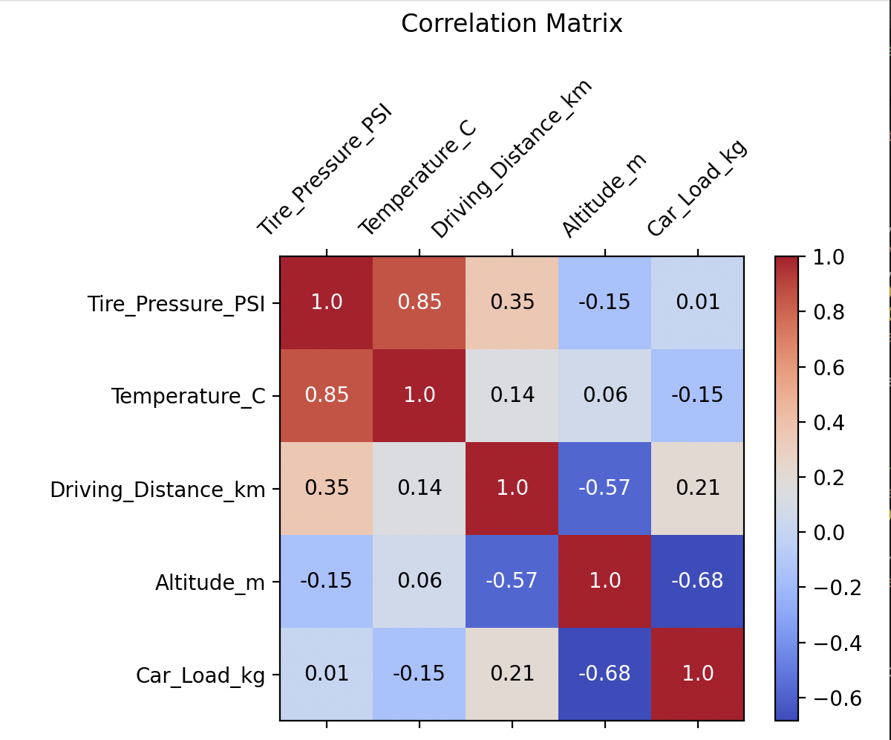

**Determined Hypotheses are as follows:**

**H1:** Tire pressure increases with outdoor temperature.  
**Result:** Supported (r = 0.851)

**H2:** Longer driving distance leads to increased tire pressure.  
**Result:** Moderately supported (r = 0.349)

**H3:** Heavier car load results in higher tire pressure.  
**Result:** Not supported (r = 0.012)

**H4:** Higher altitude has a significant effect on tire pressure.  
**Result:** Not supported (r = -0.146)

**Observations and Graphical Insights**

**Individual Graphics:**

Histogram of Tire Pressure: Shows the distribution of tire pressure values throughout the measurement period.

Boxplot of Tire Pressure: Indicates the median, quartiles, and outliers of tire pressure measurements.

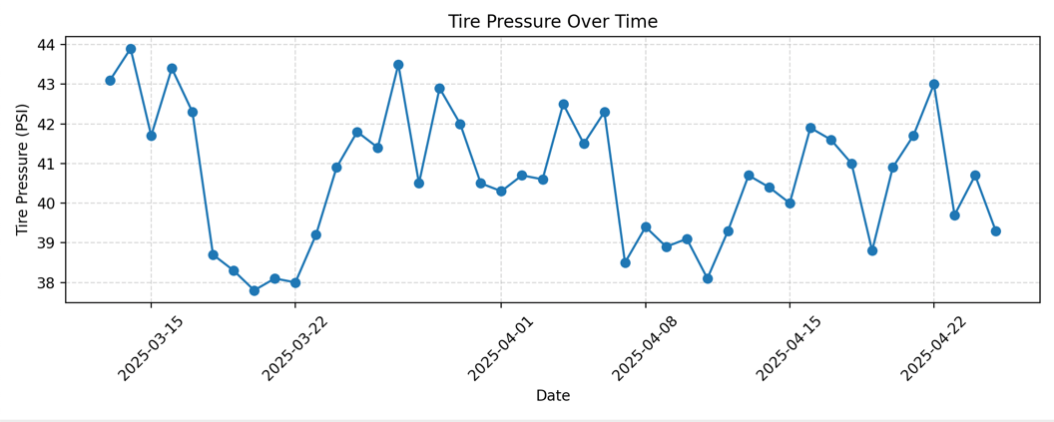

Line Plot: Tire Pressure Over Time: Illustrates daily changes and trends in tire pressure over the measurement period.

**Comparative Graphics:**

**Tire Pressure vs Temperature (**°**C)**

* **A graph with blue dots

  AI-generated content may be incorrect.**This scatter plot shows a strong positive linear relationship between temperature and tire pressure.  
  As the outside temperature increases, the tire pressure consistently rises.  
  This supports Hypothesis H1 and is confirmed by a Pearson correlation coefficient of **r = 0.851**.

**Tire Pressure vs Driving Distance (km)**

* This scatter plot shows a moderate positive relationship between driving distance and tire pressure.  
  Tire pressure tends to be higher when longer distances are driven, due to the heating of the tires during extended trips.  
  This finding moderately supports Hypothesis H2 with a Pearson correlation of **r = 0.349**.

**Tire Pressure vs Altitude (m)**

* This graph shows a weak negative relationship between altitude and tire pressure.  
  There is no clear visual pattern, and the slight downward slope indicates a very minimal decrease in pressure at higher altitudes.  
  The Pearson correlation of **r = -0.146** suggests that altitude has no significant effect in this specific dataset, thus not supporting Hypothesis H4.

**Tire Pressure vs. Car Load (kg)**

* A graph with blue dots

  AI-generated content may be incorrect.The scatter plot shows almost no visible trend between car load and tire pressure.  
  Tire pressure values remain fairly constant regardless of whether the car is heavily or lightly loaded.  
  This confirms the Pearson correlation result of **r = 0.012**, indicating negligible impact and rejecting Hypothesis H3.

**Conclusion**

* Strongly positively correlated, this project clearly shows that tire pressure fluctuations are mostly driven by temperature. Driving distance also has a small effect since longer distances tend to somewhat increase tire pressure by means of thermal expansion caused by tire heating. Conversely, although at first glance altitude and car load would influence tire pressure, in the recorded data their effects turned out to be negligible and statistically meaningless.
* All things considered, the results offer insightful information about how operational and environmental factors impact tire maintenance. Daily drivers like myself can better predict changes in tire pressure, maximize vehicle performance, improve safety, and encourage longer tire lifespan through proactive maintenance techniques by comprehending these relationships. The significance of routine tire inspections is emphasized by this study, especially after long-distance driving and during seasonal temperature fluctuations.

# **Regression Model Results**

* Two regression models were used: linear regression and polynomial regression (degree 2).  
  Linear Regression:  
  - RMSE: 0.948  
  - R²: 0.713  
  - Intercept: 35.34  
  - Coefficients: Temperature (°C): 0.386, Driving Distance (km): 0.020
* A graph with blue and orange dots

  AI-generated content may be incorrect.Polynomial Regression (Degree 2):  
  - RMSE: 0.957  
  - R²: 0.707  
  - Intercept: 35.74  
  - Coefficients: Temperature (°C): 0.177, Driving Distance (km): 0.069, Temperature²: 0.009, Temperature×Distance: 0.001, Driving Distance²: -0.001

**Final Conclusion**

The project's conclusions offer important new information about how vehicle tire pressure changes in response to operational and environmental variables. The following key findings can be made using both statistical modeling and exploratory analysis:

**1. The primary predictor of tire pressure is temperature (°C).**

**Tire pressure and ambient temperature had a strong positive correlation (Pearson r = 0.85), which amply supported the first hypothesis (H1): Tire pressure rises with outdoor temperature. This conclusion was supported by the regression models since the temperature coefficient in the linear and polynomial models was both large and statistically significant. The practical consequence is that for appropriate tire maintenance, seasonal variations and daily temperature swings need to be regularly observed.**

**2. The effect of driving distance is moderate but noteworthy.**  
Driving distance and tire pressure were found to have a moderately positive correlation (r = 0.35), which somewhat supports the second hypothesis (H2): Tire pressure rises with longer driving distances. This relationship most likely results from the expansion of tire air caused by the physical heating of tires during prolonged driving. Even so, this effect is much less pronounced than that of temperature.

**3. In this dataset, tire pressure is not significantly impacted by altitude or vehicle load.**

**Both altitude (r = -0.15) and vehicle load (r = 0.01) showed very weak relationships with tire pressure, in contrast to the original hypotheses (H3 and H4). Since neither variable significantly affects tire pressure within the context and range of this dataset, the statistical analysis is unable to reject the null hypothesis for either factor. As a result,**

* **H3: "Higher tire pressure is caused by a heavier car load" is disproved.**
* **H4: "Tyre pressure is significantly impacted by altitude" is disproved.4. Model evaluation and predictive insights.**

**4. Predictive insights and model evaluation.**  
Although both linear and polynomial regression models demonstrated good performance, linear regression had a marginally better fit (R2 = 0.713, RMSE = 0.948). The regression scatter plot shows how closely the predictions matched the actual values. The overall linearity of the relationships in the current data was supported by the lack of significant improvements produced by the polynomial model.

**5. Recommendations and practical implications.**  
Car owners should check and adjust tire pressure more frequently during hot or cold spells because of the strong temperature dependence of tire pressure. Longer journeys might need the same level of care. For routine maintenance, altitude and vehicle load are less of a concern, unless there are exceptional circumstances that were not included in this study.

**6. Limitations and further work.**  
The study's geographic/operational scope and sample size (just over a month) are its main limitations. Generalizability may also be limited by fixed car/route conditions and manual weather recording. Larger datasets, automated weather and traffic logging, and an examination of interactions or non-linearities not evident here should all be part of future research.